***Rohan Borse***

***Hadoop Notes.***

***Hadoop 1 VS Hadoop 2***

* Hadoop 1 have HDFS and MapReduce
* Hadoop2 have HDFS and YARN/MRv2

HDFS use for Storage and Mapraduce nad yarn use for the data Processing

**Working :**

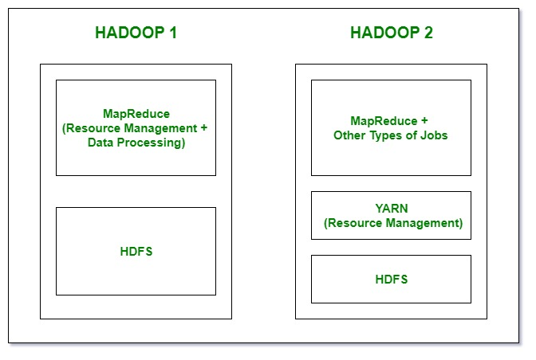

**Limitation of the Hadoop 1 :-**

* Single Point of Failure
* Low Resource Utilization
* Less Scalablity When Compare to the Hadoop 2

**Hadoop EchoSystem :-**

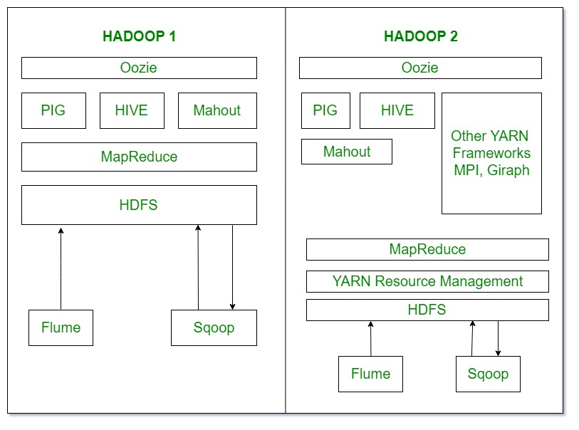

**Oozie :-** we can call Oozie as Work Flow Schedular

**PIG, Hive, Mahout :-** this are the tool that work on top of Hadoop for the Data processing

**Sqoop :-** Use for the import and Export the Structured Data we can directaly import and export the

data from the sql using the Sqoop

**Flume :-** import the unstructured Data and import the moving Data